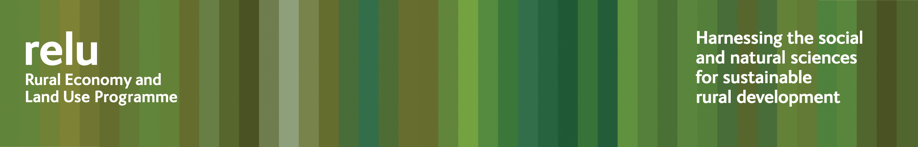

PRESS RELEASE – IMMEDIATE RELEASE

26 November 2009

Schools welcome Bangor University Bug Man

The “Nit Nurse” may be a thing of the past but the “Bug Man” has been turning up in schools all over Wales – and both teachers and pupils have given him a big welcome.

Microbiologist Wojciech Waliszewski has been ensuring school students get an insight into the risks posed by pathogens such as E coli O157 and other food-borne infections.

Based at Bangor University, he is part of an interdisciplinary research project investigating the risks of E coli O157, funded by the UK Research Councils’ Rural Economy and Land Use Programme. The workshops are part of a Local Authority Research Council Initiative that aims to take cutting edge science into schools and local communities.

Wojciech Waliszewski said: “The school students are a very receptive audience. Many of those taking part have come to talk to me afterwards, wanting to know more about my work at the university.

“Showing them simple things, like how many bacteria grow in a Petri dish, just from their own fingerprints, is a very effective means of encouraging thorough handwashing.

“We know from recent news stories just how serious infections like E coli O157 can be, and the work going on within our project is helping us to understand more about the bacteria involved, but it’s important to get the messages out to communities. Schools seem like a good place to begin.”

Samantha Berry, Teacher in Charge of Applied Science at Ysgol Friars in Bangor, added: “The workshop provided an opportunity for the pupils to have a hands-on microbiological experience alongside the knowledge of an expert, which in my eyes is invaluable for pupils studying science ‘A’ level. The pupils gained a lot from the session and it will spur them on to develop successful portfolios for their course work.”

Over 475 pupils, aged between 12 and 17 years, in 15 schools, have taken part in the workshops.

Notes for editors:

- A photograph is available for publication showing Microbiologist Wojciech Waliszewski with Year 13 Applied Science pupils at Ysgol Friars in Bangor.
- For more information about the research project see http://www.abdn.ac.uk/reluecoliproject/index.htm
- The Rural Economy and Land Use Programme is an inter-disciplinary collaboration between the Economic and Social Research Council (ESRC), the Biotechnology and Biological Sciences Research Council (BBSRC) and the Natural Environment Research Council (NERC), with additional funding provided by the Scottish Government and the Department for Environment, Food and Rural Affairs. See www.relu.ac.uk for more information about the Relu programme.
- The Local Authority Research Council Initiative (LARCI) provides a response to the growing demand on local authorities for evidence-based policy making. LARCI brings local authorities and Research Councils into closer partnership, leading to better informed research, policy and practice, and facilitating knowledge exchange at a strategic and operational level. Input from local authorities helps the Research Councils ensure the projects they fund have practical applications; using Research Council-funded research helps local authorities ensure their policies are based on reliable information. See http://www.rcuk.ac.uk/innovation/partnership/larci/default.htm for more information.
- For any other information contact Anne Liddon, Relu Communications Manager, anne.liddon@ncl.ac.uk tel 0191 222 6880.
ends

